

Cecil Andrews College

Electricity Test - 2023

44

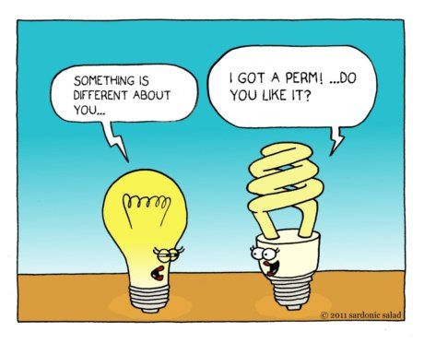

Student name: ________________________

# TIME: 1 Hour

**NOTE:**

1. Calculation questions must be structured and show clear working with answers stated to **three significant figures.**

2. **Marks will be allocated for clear and logical setting out.**

Answer

3. Place your final answers in the box provided. Eg.

4.State assumptions if working on open ended type questions.

**Q 1.**

1. Which of the following graphs best represents a non-ohmic conductor? (1 mark)

Answer:

I

I

I

I

V

V

V

V

[A] [B] [C] [D]

1. Explain your reasons why you selected this graph. (2 marks)

|  |
| --- |
|  |
|  |
|  |

**Q 2.**

Explain why the metal copper is a better electrical conductor than rubber. (2 marks)

|  |
| --- |
|  |
|  |
|  |
|  |
|  |

**Q 3.**

When a resistor is connected to a 9 V battery, 1.57 × 1021 electrons pass through the resistor in a time of 90 seconds.

a) Calculate the current in the resistor. (2 marks)

b) Calculate the work done on the electrons by the battery. (2 marks)

**Q 4.**

A television is rated at 240 V, 150 W and is operated for five hours a day, seven days a week for 52 weeks.

a) How much energy (in kilowatt-hours) will the TV consume in that time? (3 marks)

b) If a kilowatt-hour costs 16 cents, find the cost of the electricity consumed by the TV in one year? (1 mark)

**Questions** **5** **to** **8** uses the following circuit diagram showing the connections of three resistors (labelled R1, R2 and R3) with the same values.  
With the switch (S1) **closed**, answer the questions below.

C

E

F

G

A

B

D



R2



R1



R3

S1

**5**) The direction of conventional current flow is from: (1 mark)

Circle the correct answer: G to A B to A D to A

**6**) To determine the potential difference across resistor 2, you would use the points: (1 mark)

Circle the correct answer: A and C A and F B and C

**7**) There is no potential difference between the points: (1 mark)

Circle the correct answer: A, D and G A, B and C E, F and G

**8**) Comparing the amount of current going through points A, D and G, the order from the greatest amount of current to the least is: (1 mark)

Circle the correct answer: A, D then G G, A then D G, D then A

**Q 9.** A student completes an electric circuit that includes a mystery box as shown below.

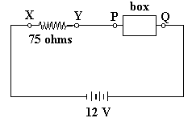

If the potential difference between X and Y is 9.0 volts,  
which of the following boxes – A, B, C or D – would be the mystery box?  
Write your answer in the square box. (1 mark)

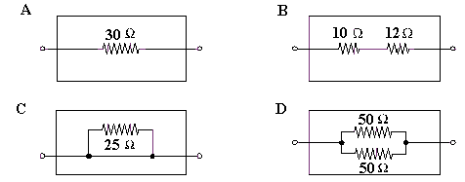

Write your answer here.

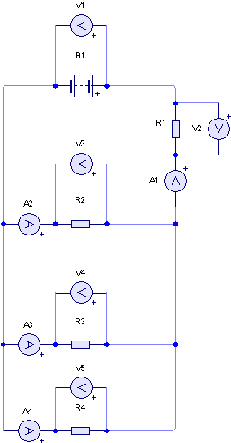**For Questions 10-12 consider the following diagram**

**10)** Write a mathematical relationship between V1, V2, V3, V4 and V5? (1 mark)

_____________________________________________________________________

**11)** Write a mathematical relationship between A1, A2, A3 and A4. (1 mark)

____________________________________________________________________

**12)** If R1, R2, R3 and R4 are all 30.0 Ω resistors, what is the total resistance of the circuit? (2 marks)

**Q 13.**

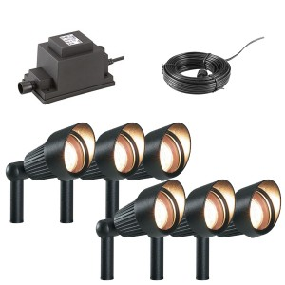

A garden lighting system consists of 4 (four), 13 Ω lamps, connected in parallel. The system is driven by a 12 V solar panel. A safety feature of the circuit is a fuse, which is designed to cut the power if the current in the circuit exceeds 8.00 A.

Not happy with number of lamps, a home handyman wanted to connect extra lamps in parallel with the existing lighting system.

**a)** Draw the electric circuit for the existing four lamp lighting system. (3 mark)

**b)** How many lamps can he have in the system without blowing the fuse? Show all calculations required. (4 marks)

**Q 14.**

During a practical lesson a group of students constructed a circuit that contained a 40.0 Ω resistor, a 20.0 Ω resistor and a lamp (‘A’), in parallel with each other. This combination was then placed in series with a 50.0 Ω resistor, as shown below. The lamp had a resistance of 40.0 Ω and the circuit was connected to a power pack set on 12.0 V.  
For this question, assume that Lamp A was an ohmic resistor.

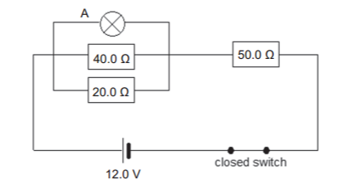

1. On the diagram above, use an arrow to indicate the direction of electron current in this circuit. (1 mark)
2. Calculate the total resistance of the circuit. (2 marks)
3. Calculate the total current in the circuit. (2 marks)

(d) The students then used a voltmeter to measure the potential difference across  
the 50.0 Ω resistor.

1. On the diagram on page 8, draw how they would have connected the voltmeter to the circuit. (1 mark)
2. Calculate the potential difference across the 50.0 Ω resistor. (2 marks)

(e) Determine the power dispersed in the 50.0 Ω resistor. (2 marks)

**Q 15.**

**a)** Draw a circuit containing a power supply, a globe, a closed switch and a fuse. Include in your diagram a bare piece of wire which short circuits the globe, that is, stops the globe from glowing. (2 marks)

b) Use dot points to explain why the fuse may blow in this short circuit situation. (3 marks)

**END OF TEST, PLEASE CHECK YOUR ANSWERS**